**Muscles of the Eye Labeling Activity**

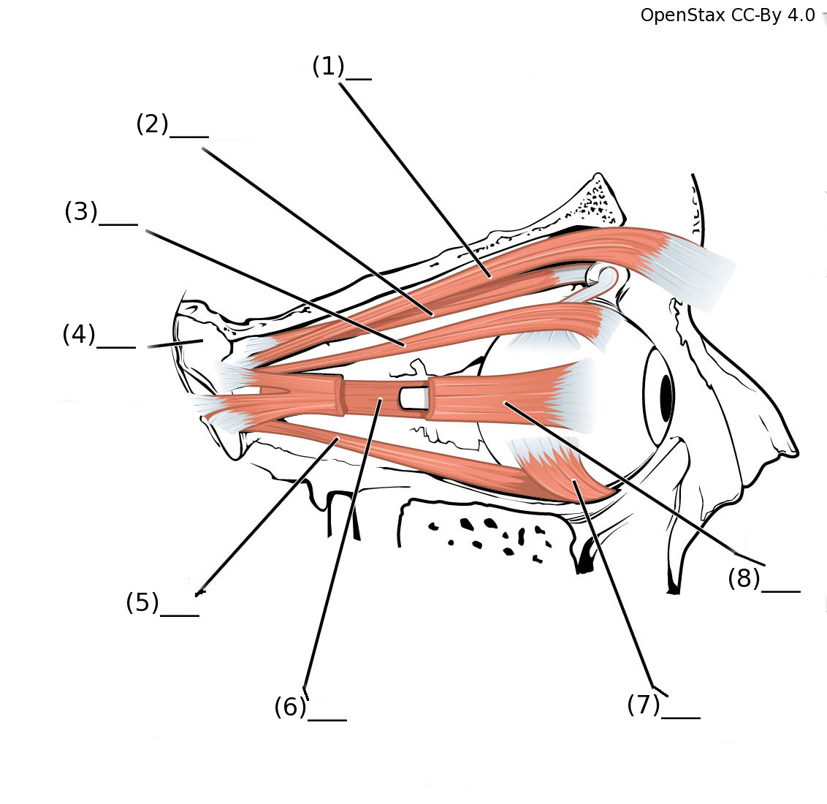

Word Bank

1. Lateral rectus
2. Superior oblique
3. Medial rectus
4. Inferior rectus
5. Sphenoid Bone
6. Superior rectus
7. Levator palpebrae superioris
8. Inferior oblique

Answer Key

1. Levator palpebrae superiors
2. Superior oblique
3. Superior rectus
4. Sphenoid bone
5. Inferior rectus
6. Medial rectus
7. Inferior oblique
8. Lateral rectus